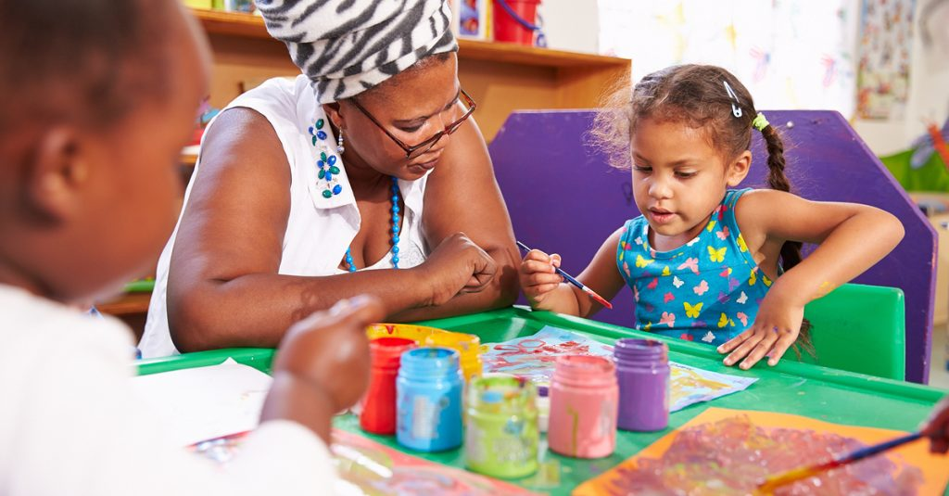**Family Activity Booklet**

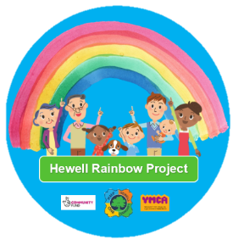**HMP Hewell** **Rainbow** **Project**

March 2021 **HMP** Hewell Rainbow Project

Hello

Here at YMCA ‘s ‘Hewell Rainbow Project’ we are ready to support you and your little ones at home during this challenging time.

We have compiled some creative ideas that are both resourceful and inexpensive. Not only will they keep you and your child/children busy, but some of the activities are designed specifically to help you in a supporting role. Your child/children may be anxious and be finding it difficult to cope with Daddy, or any other significant male in your child/children’s life, being ‘away’ from them.

Whether you and your child/children are struggling with separation, or you are counting down the days until he comes home, there are many activities to choose from.

We hope you enjoy creating memories and would love to hear not only your feedback, but any ideas that you or your child/children may have to add to this booklet so please do share with @hewellrainbow (Twitter) or via YMCA-https://ymcaworcestershire.org.uk/what-we-do/family-work/rainbow-hmp-hewell-project/

You are doing great!

Thank you for all your contributions.

Nicki, Helen and the Children & Families Team

Disclaimer. 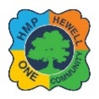It is recommended that all activities in this brochure are supervised by an adult. Always take safety precautions when taking part in craft and activities. Always follow the labels of the ingredients and resources used. Always use judgment on age-appropriateness and do not let children under 3yrs, participate with any small ingredients or supplies that could pose a choking hazard. Please have fun but stay safe ☺

Memory Book

**What is the activity?** Create a Memory Book to share.

**What resources do I need?** Scrapbook/Photo album/photos/ stickers/magazines etc. /Glue/scissors.

**How do I do this?** 1. Choose a special activity to do each day, for example, paint a picture, go for a nature walk, bake some biscuits, make a simple sandwich for a picnic etc.

2. Take a photo and either print them yourself (if you have a printer) or upload to a free printing app. (Snapfish/photobox etc. you can get 50 free prints a month and only pay postage).

3. Decorate a scrapbook/photo album with some stickers, pictures cut out from magazines or catalogues (Argos etc.)

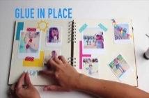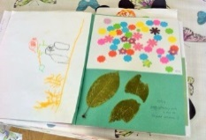This is a great way to stay positive and encourage communication. The photos and special book can be shown to Daddy etc. via Purple Visits and will spark many conversations plus you will have a beautiful book to keep to share with him when he returns.

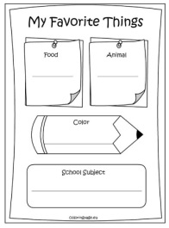 Another idea for creating memories is to download or print memory sheets to colour and fill in. There are some great ones on Pinterest.com

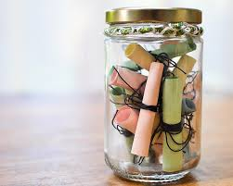Wish Jar

**What is the activity?** Make a Wish Jar

**What resources do I need?** An old jar with a lid plastic container/ paper/pens/stickers and crayons

**How do I do this?**

1. Choose a jar or container and think of all the of activities that you would like to do when he comes home, for example, go to the park, read a story, have a picnic. Decorate the jar with stickers/photos etc.

2. Either write or draw a picture to fill the jar so when he does come home, you can choose a special activity each day. You can also ask him on the phone/during purple visits/in a letter.

3. You can adapt this idea by writing down all of the funny little things the child/children say or do, e.g. telling a funny joke. Again, write this down and put inside a jar. You can save these for when him when he comes home or read them out to him on a purple visit. .

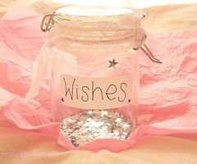4. If your child/children feel anxious, you can also make a worry jar. Write the worries down on little slips of paper and put them into a jar or container. Simply fill the jar with water, a drop of oil and glitter or food colouring (Make sure the lid is secure!) Your child can then share their worry while shaking it away. For younger children you use an empty plastic bottle with the lid tightly screwed on.

**This** helps you and your children to look forward and plan for a future with Daddy etc. with you. It can reduce anxiety as it helps you to have a positive frame of mind

BINGO!

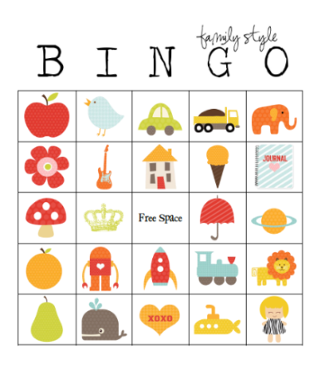**What is the activity?** Make your own bingo boards. You can do this together by finding photos of special times spent together, photos of family members or pets anything that is special to you all

**What resources do I need?** Glue/crayons/felt pens/scissors/stickers etc. there are plenty of pre-printed cards available online ready to print or your child can draw or colour their own pictures. You could use photos/stickers/ foam shapes etc. these can be stuck onto card or paper and backed onto thicker cardboard from a cardboard box or cereal box.

**How do I do this?** Print or draw bingo card onto card or paper and stick onto card cut from a cardboard box. You could print or draw a table with lots of squares on and fill each square with a picture/shape etc

This is a great way of building self-esteem, remembering special, happy memories or supporting new learning by recognising and naming colours/ shapes/animals/foods any groups.

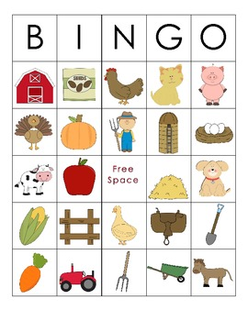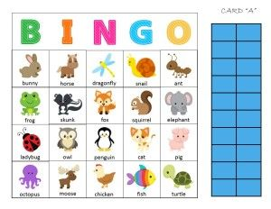

Den Making

**What is the activity?** Making a Den

**What resources do I need?** Spare blankets/towels/sheets etc. clothes pegs, pieces of ribbon, wool. Two chairs back to back/table big enough to get under. Outside- tree.bench etc.

**How do I do this?** Using spare blankets, sheets and clothes pegs along with chairs simply cover making a comfortable den for your child. You can add cushions, fairy lights and your child’s favourite soft toys, books to make the den have a homely feeling.

This is a fun idea which is simple and cheap. Children often feel happy and safe enclosed in a den. If your child is feeling anxious and in need of reassurance then dens can be a place of safety which will enable your child to feel secure.

Why not introduce an indoor picnic or story time

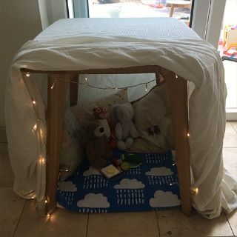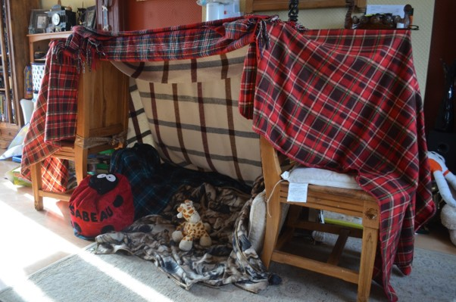

Picnic Time

**What is the activity?** A picnic for you and your child/children, friends or teddies, dolls etc.

**What resources do I need?** Blanket or rug, paper plates, cups, cushions, children tea set (make sure it’s clean!), picnic food - salad. cheese, sandwiches, crisps, drinks etc.Toys, dolls, teddies,dinosaurs.

**How do I do this?** You could set the picnic up as a surprise or involve the child/children. This could be either indoors (maybe in a den inside or outside in the garden or park if the weather allows, a picnic is a great idea to get your children involved in cooking and choosing what they would like to eat and drink. Children can choose the filling in a sandwich, butter the bread or help to pack the bag or lay out the blanket. Food can be packet in boxes/lunch boxes or bags.

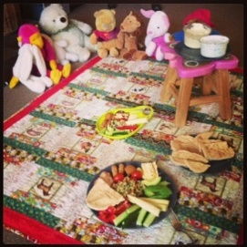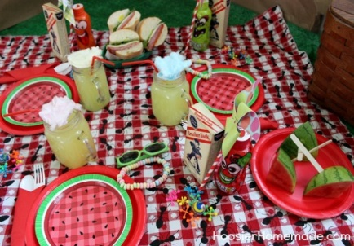

Children often try new tastes if they are involved in the preparation of their food. Picnics can be useful in introducing new foods or simple social skills. Eating in a different environment – on a blanket, outside etc. can often take the heat out of mealtimes which, for many, can often be a battleground. No cutlery needed! It is also lots of fun!!

Cinema Time

**What is the activity?** Creating a cinema to watch favourite films or cartoons.

**What resources do I need?** Paper and crayons or felt pens to make cinema entry tickets. Comfy cushions on the floor in the lounge (or wherever the television is) or dining chairs, children’s plastic chairs in a row. Optional snacks – popcorn, crisps, a few sweets, fruit. DVDs or videos depending what machines you have or children’s film channel/cartoons.

**How do I do this?** Your child/children may miss or have never visited the cinema before, or they may have a favourite film or a film that they really want to see. Why not speak to family or friends and see if you can set up a swap shop? Being careful due to COVID of course, (sanitising and quarantining DVD’s before safely exchanging).

You can then enjoy a film together. Maybe close the curtains, grab a duvet/blanket.

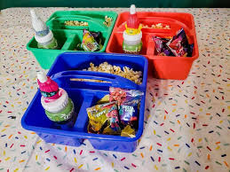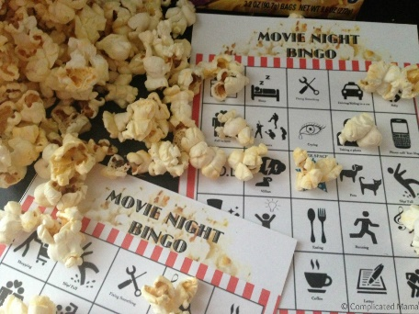

Take an Internet Tour

With popular attractions being closed at the moment, you may be missing getting out and about. Have you tried an internet tour?

Whether it be a zoo, aquarium or museum there are plenty to choose from and they are usually FREE!!

Here are a few to get you going…

<https://seaworld.com/at-hoe/>

<https://kids.sandiegozoo.org/videos>

<https://www.nasa.gov/mission_pages/station/main/suni_iss_tour.html>

Homemade Playdough

This recipe makes a lovely, stretchy, springy playdough at a fraction of the price of play dough bought from the shop. It is made with natural ingredients and is long lasting if kept in an airtight container. Don’t worry if you don’t have any playdough tools. Household items work just as well! Let them use a fork, a plastic cup, cupcake cases, a tin for rolling etc. etc. Sprinkle a little flour and watch your little ‘Bake Off’ experts create their masterpieces.…

Play dough is very therapeutic.

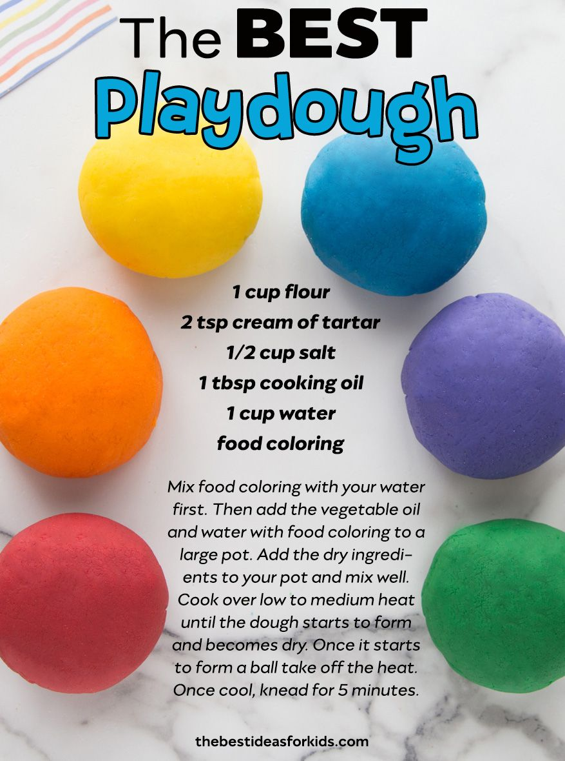

You can roll it gently, bash it, squeeze it between your fingers, pinch it and poke it.

Try it yourself it is very tactile.

You never know, this may inspire you to make some pastry or bread with your little ones. Then you can tell daddy (or whoever you visit) about your new found skills.

Countdown/behaviour chart

These are tried and tested methods to help your child/children count down those long days until he comes home or to reward good behaviour. There are lots of templates online, or you can make your own by drawing a tree and encouraging your child to add a leaf or an apple when they are praised. As a reward, maybe offer a trip to the park or an extra story at bedtime.

C:\Program Files (x86)\Microsoft Office\MEDIA\OFFICE14\Bullets\BD21421_.gif

C:\Program Files (x86)\Microsoft Office\MEDIA\OFFICE14\Bullets\BD21421_.gif





C:\Program Files (x86)\Microsoft Office\MEDIA\OFFICE14\Bullets\BD21421_.gif

If you do not have stickers, why not use crayons or finger paints?

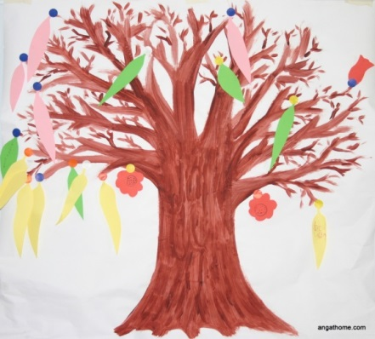



Let’s Get Moving

Why not try yoga? This teaches children of all ages the importance or taking care of themselves, relaxation and is fun when trying to pose the different positions! If you have ‘YouTube’ there are FREE online classes to join in with.

Inside… or outside…

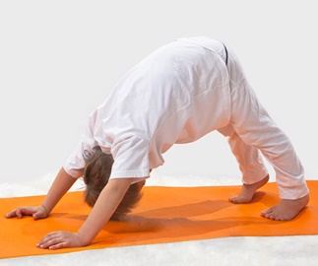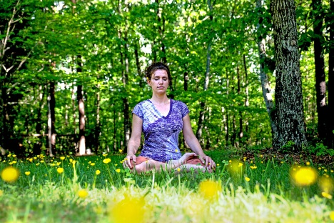

Obstacle courses

Make an obstacle course! Inside - jump over the cushions, crawl under the blanket, walk sideways around the paper plates and try and throw a ball of socks into a basket… Make sure you move your ornaments to a safe place!

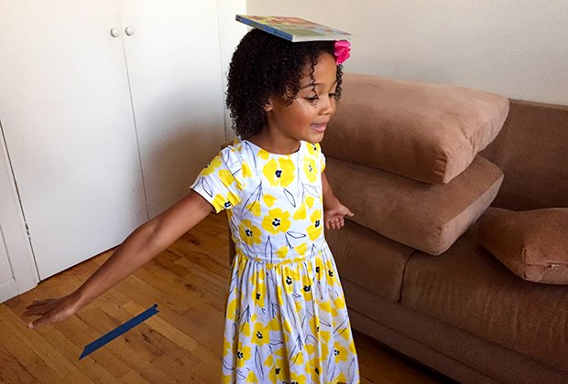Outside- use skipping ropes, hoops, bean bags, balls and make your own obstacle course in your garden.

Physical activity will certainly tire your little one out phew! Easter/Spring Printing

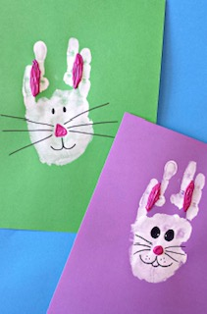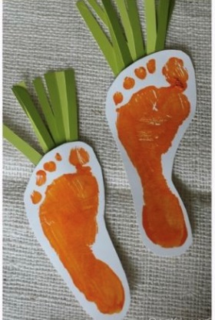

Rabbits! Carrots!

Handprints with white paint Footprints with orange paint

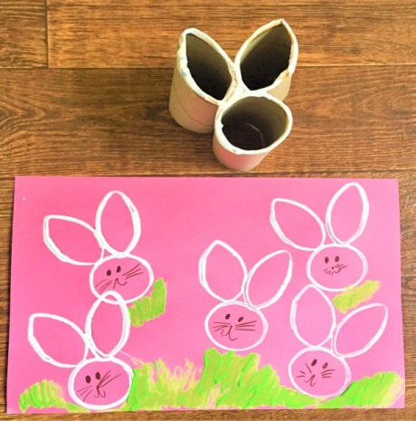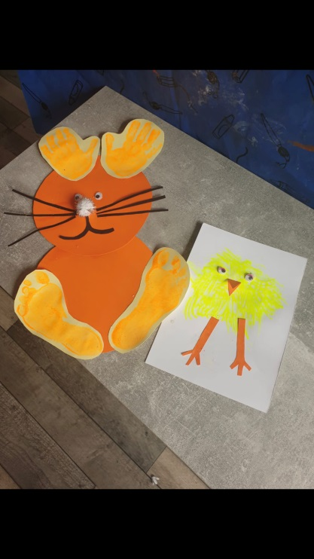

Kitchen roll rabbits Hand and foot rabbits and chicks

Easter Collage

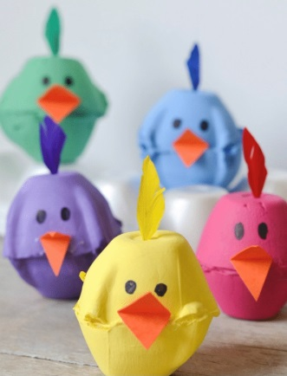

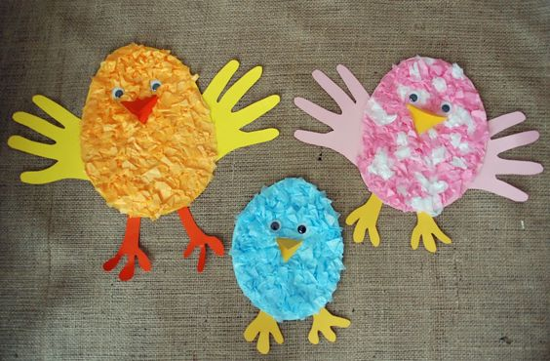

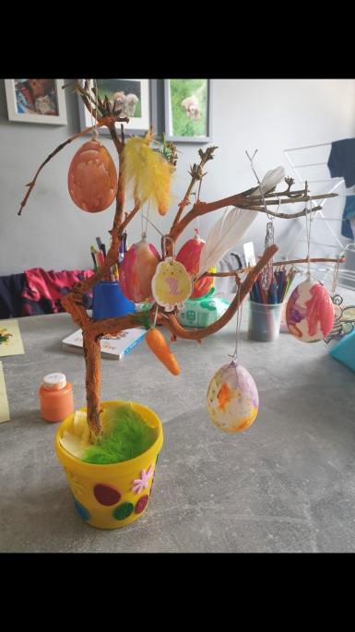 Egg box chicks Tissue paper chicks/birds

Easter Tree to show off your creations

Happy Easter!

Nature Walk

With Spring upon us, there are plenty of new and exciting things to spot when you are out and about. You could make a checklist by using old magazines.

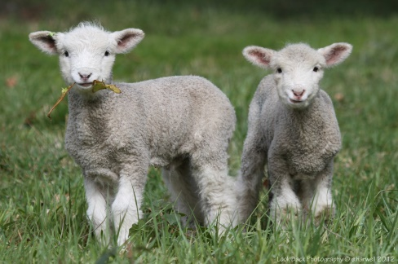



Lambs…Check

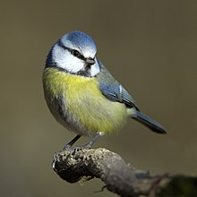



Birds…Check





Daffodils…Check

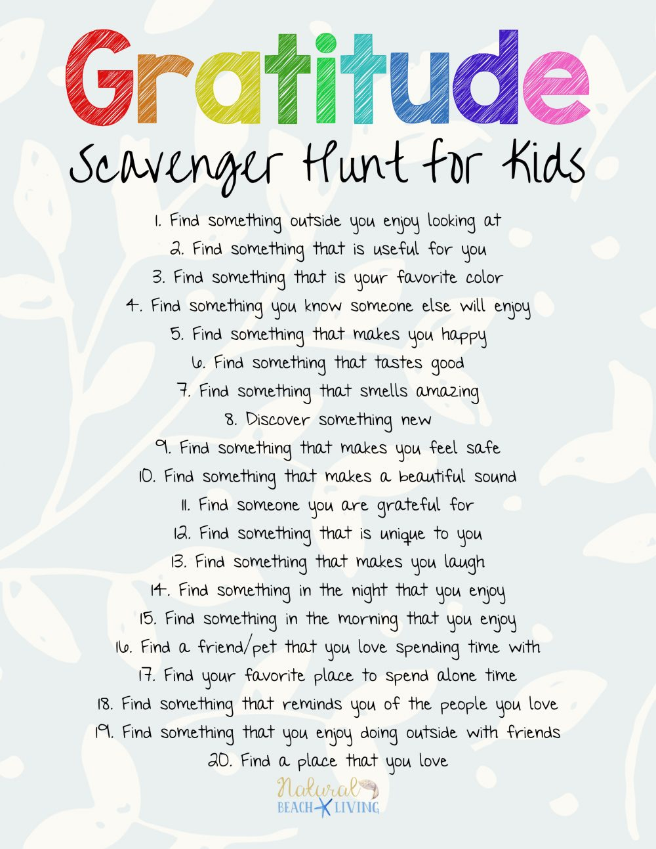

Outdoors

Looking at shadows

You could use anything for this, not just dinosaurs! Use your child’s/children’s favourite toy, food, teddy’s etc. Encourage your child to look and copy the shapes the shadows make. They could then colour or paint them.

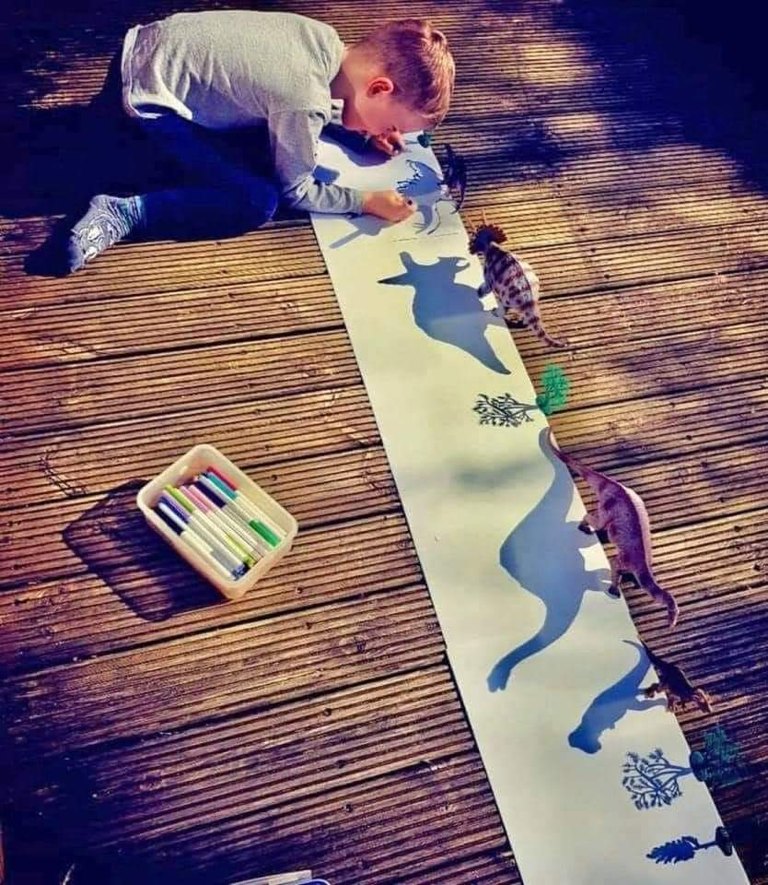



A Day at the Salon - Enjoy a pamper day!

* Make a face mask from oats, honey, yoghurt and water. https://www.google.com/search?q=face+masks+oats&oq=face+masks+oats&aqs=chrome..69i57j0i22i30l3j0i390l3j69i64.4803j0j7&sourceid=chrome&ie=UTF-8
* Put cucumber on your eyes
* Massage each other’s feet, necks and hands
* Try a new hair style
* And don’t forget the nail polish. Toes are a good place to start!
* Draw around hands so your child/children can practice, making their own nail designs
* Practice hair styles on dolls (Girl’s World ) remember to keep scissors out of reach!

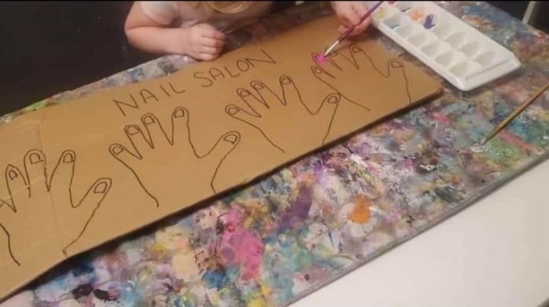

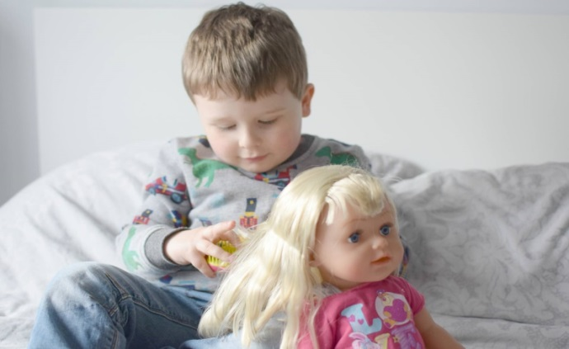

Fun with Cardboard - Recycling

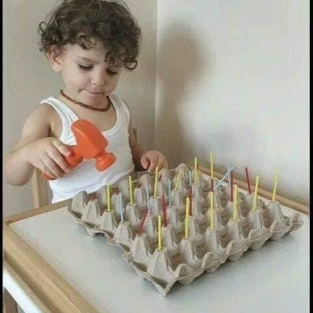There are so many ways to make new things out of old cardboard. It is cheap and a great way of re-using before re-cycling. Here are a few ideas but you can probably think of many more using packaging you would usually through away….

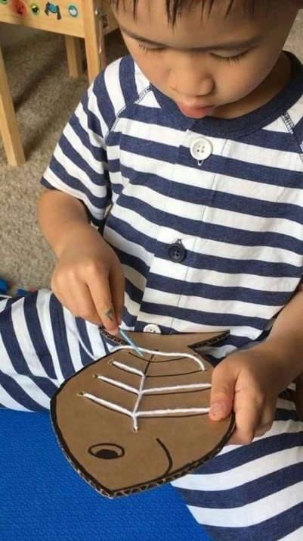Children can practice their hand-eye co-ordination.

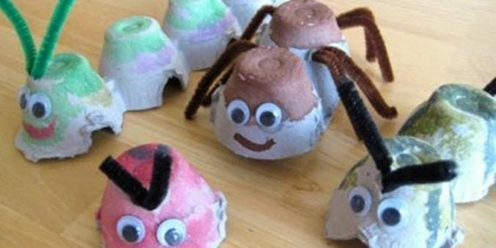

Plastic needles can be brought online e.g. Baker Ross

<https://www.bakerross.co.uk/catalogsearch/result/?q=needles>

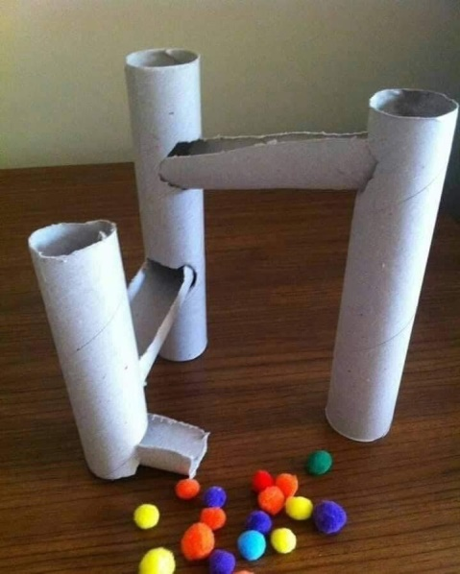A simple marble run.

If you do not have any marbles then you could use pom poms or pebbles from the garden.

Round sweets, Malteasers, Skittles.

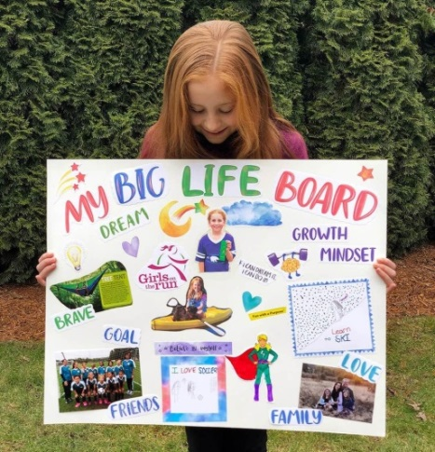

Make a happiness vision board using an old cardboard box as a backing, decorate and fill with photos, pictures, drawings and positive sayings. This is great for an older child who is struggling during lockdown or who is missing a family member.

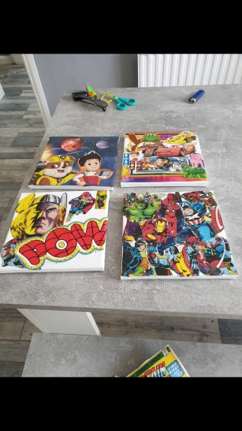Using favourite wallpaper samples from B&M, B&Q or Wilkinson, cut to size and glue onto a canvas or sturdy piece of cardboard to make an inexpensive picture. These can be protected with watered down PVA glue once dry it forms a clear shiny surface

Moving onto Mindfulness

There are many websites available giving advice and support on how to keep yours and your child/children’s minds healthy. This one below has great ideas and uses visuals to make them appealing! Give them a go or find your own online.

The way to support a healthy mind is to;

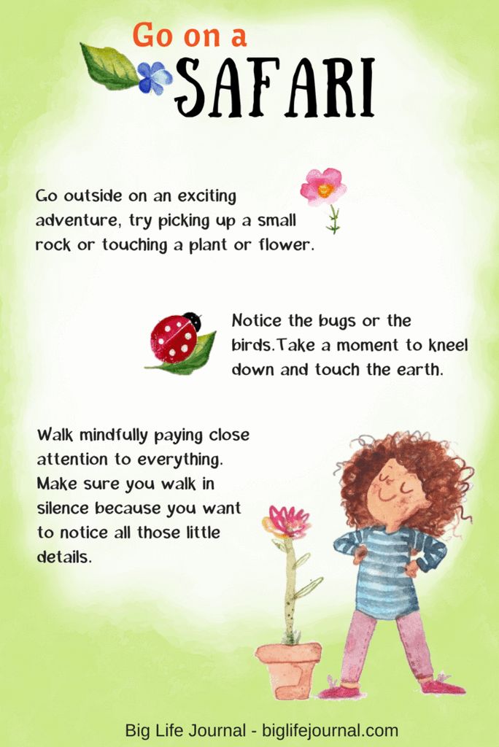Look at nature and our outside environment

Learn Breathing Techniques.

Notice how you are breathing and make a conscious effort to control and practice slowing it down so you feel relaxed. Practising a technique may help at times of anxiety and stress.

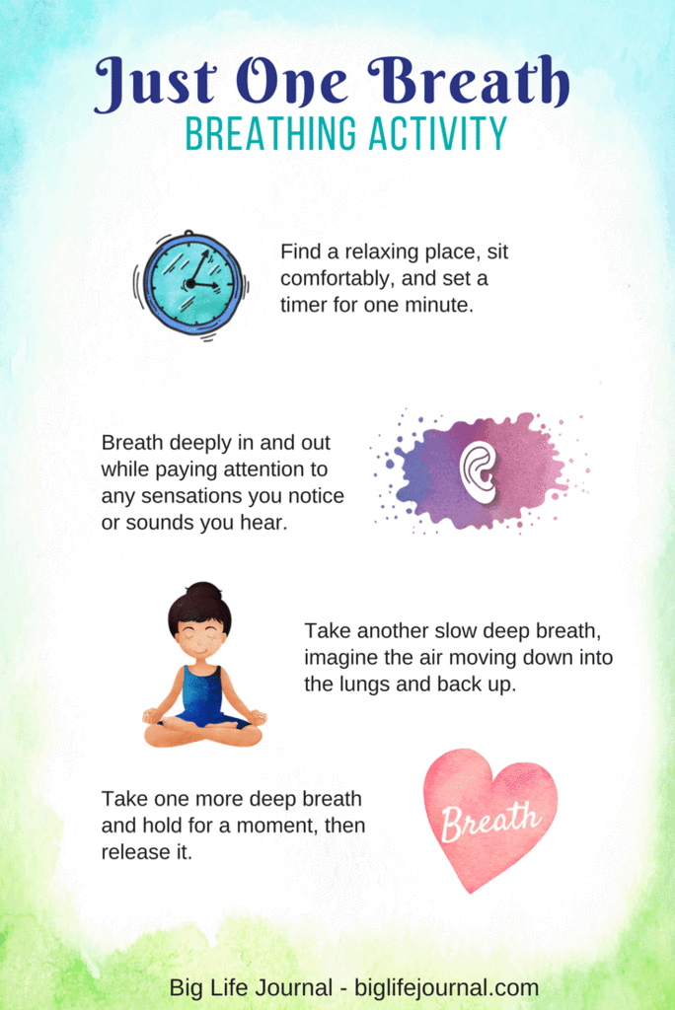

Relaxation Exercises

Spend 5 minutes or longer learning a new relaxation exercise. You and your child/children can lie on the floor or sofa, with a blanket and enjoy this together. Great when the children need to release some tension or energy!

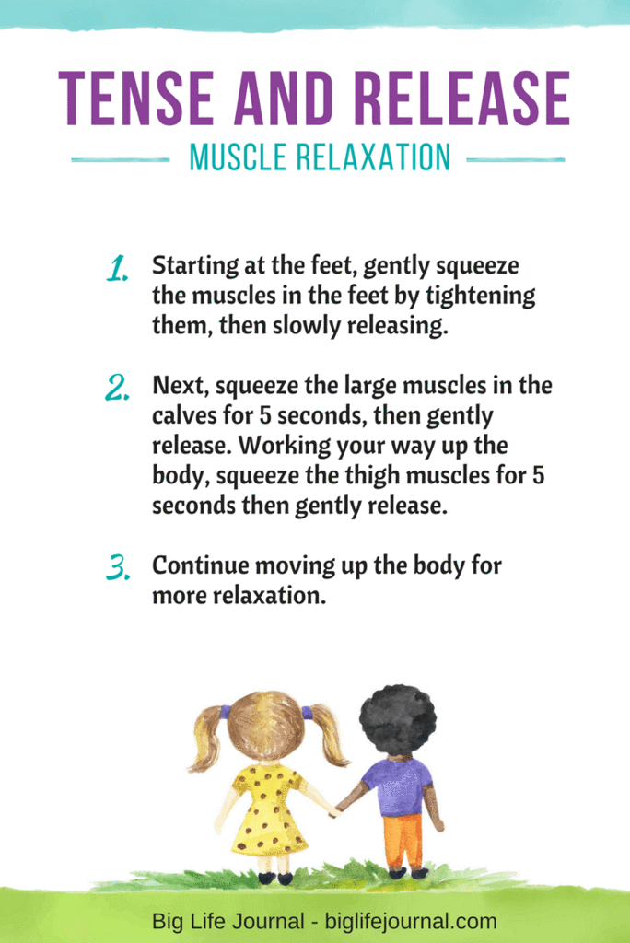

Exercise

At the other end of the spectrum get exercising! There are so many exercises you and your child/children can enjoy together, including running, walking, skipping, trampoline, roller skates, weights using bean tins…the list is endless and will release those feel good hormones ‘endorphins’.

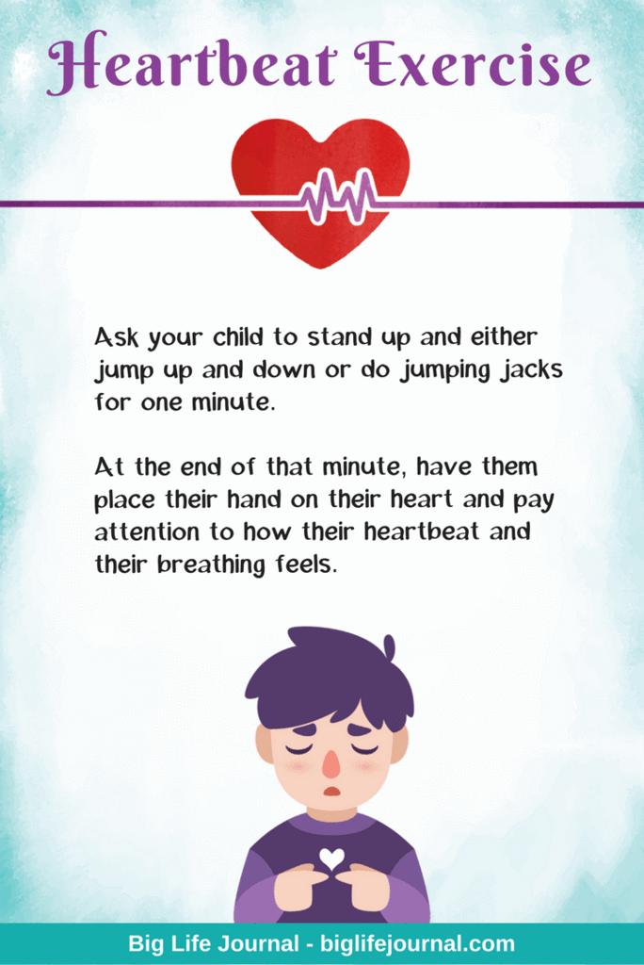

Talking about Emotions

Naming emotions can be quite powerful and give ownership to your child/children’s feelings, also teaching them how to deal with them safely and in an acceptable manner.

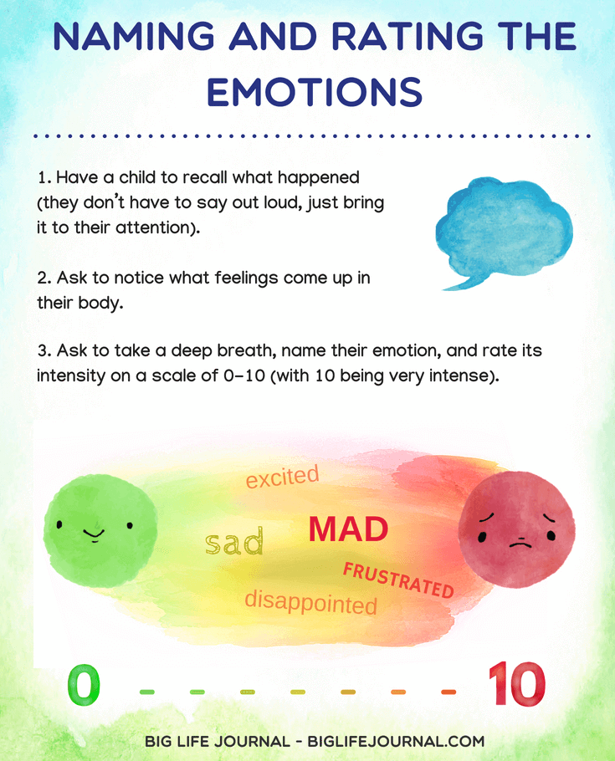

This is a great way of encouraging your child/children to think of their own coping strategies when feeling upset, stressed or anxious.

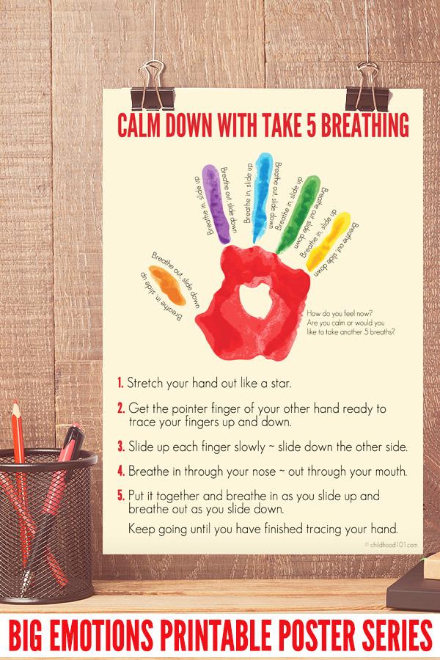

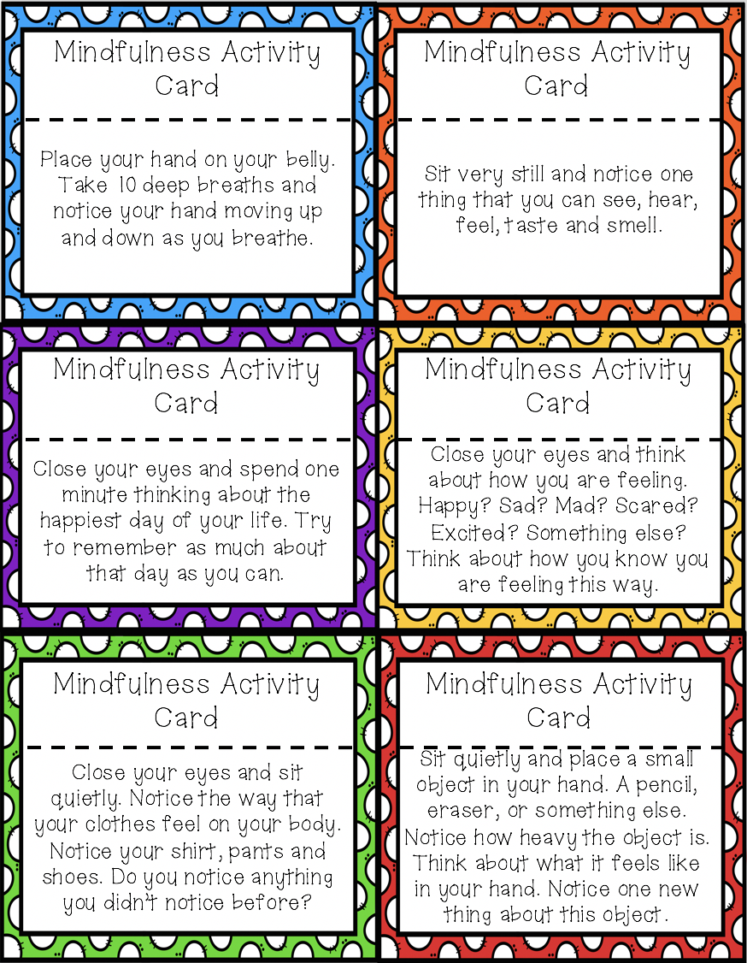These cards can be printed and cut out, or you could make your own. By choosing a card a day it is a simple and effective was of spending a short amount of time being mindful of our bodies and the environment around us.

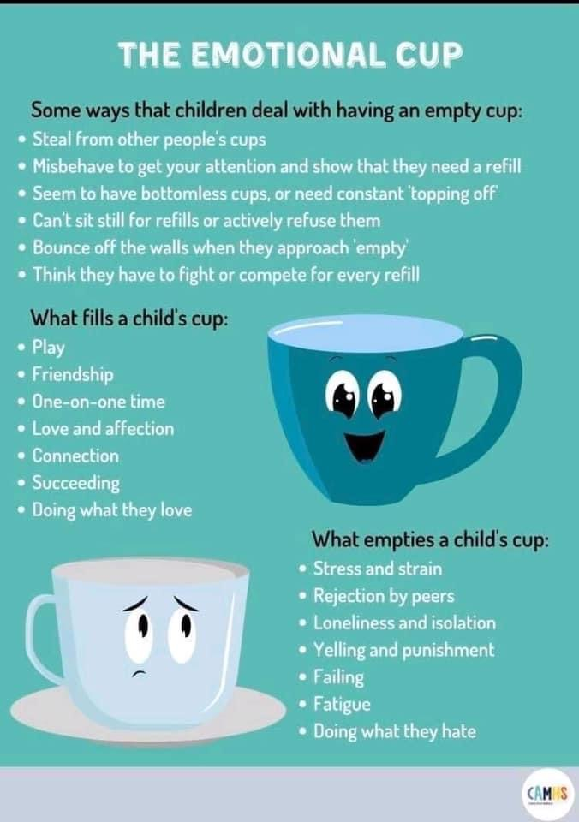Sometimes called the ‘Emotional Bucket’. Some people’s (or children’s) buckets or cups can be fuller than others, making it easier or less time for these emotions to fill up and spill over the edge. Here is a simple visual to show an example.

When we are upset, you may feel a sense of relief after a good cry. Although we do not like seeing our child/children upset, this may be true for them also. By offering support, your child will feel listened too and their feelings valid and valued.

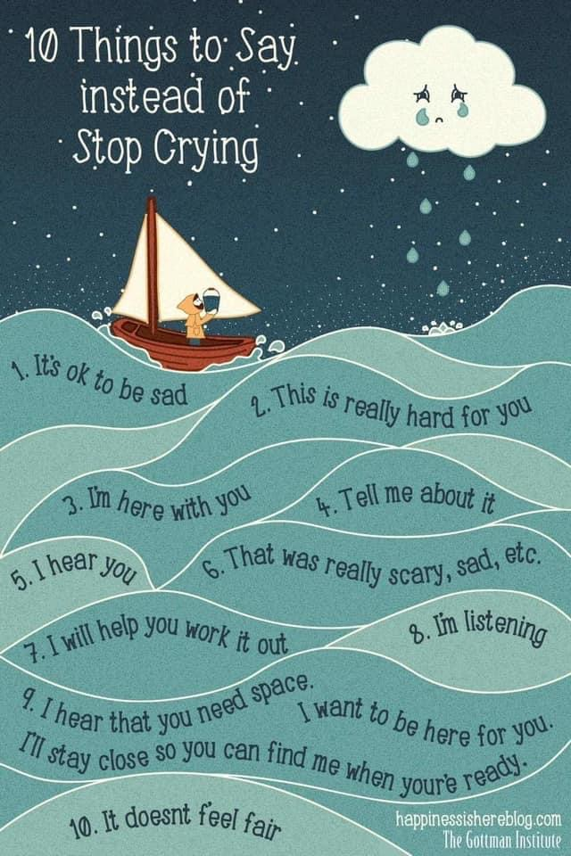

Mindfulness colouring can be a good way of keeping calm, relaxed and your mind distracted for both you and your child/children. There are many sites online offering mindfulness colouring that are free to print, along with colouring books that can be bought from The Works, Amazon, Tesco etc. which can be fairly cheap.



Useful Contacts for Support

**HMP Hewell**

**Nicki Harris** – Children and Families Manager - 01527 785124

**Hewell Visitors Centre** – Helpline for visitors.

Family Support workers or Barnardos 01527 785242

**Chaplaincy Department**– 01527 855114

**Safer Custody Helpline** – 01527 785150

**Purple Visits** (video visits) – To book a visit you must download the app and follow the instructions.

**Booking Line** –0800 3169048 book a visit when they reopen.

**Other Organisations**

**Samaritans** – Freephone – 116123 or email [jo@samaritans.org](mailto:jo@samaritans.org)

**YSS**- Worcestershire – Families First – yss.org.uk – help and support for families affected by imprisonment in the Worcestershire area.

**Childline** – Freephone – 08001111 - <https://www.childline.org.uk/info-advice/>

**Children Heard and Seen** – <https://childrenheardandseen.co.uk/>

**Children’s mental health** - [www.youngminds.co.uk](http://www.youngminds.co.uk) -

**YMCA** – <https://ymcaworcestershire.org.uk/>

Useful Websites for Resources

Baker Ross -https://www.bakerross.co.uk/catalogsearch/result/?q=needles

Hobbycraft - <https://www.hobbycraft.co.uk/>

Amazon -<https://www.amazon.co.uk/s?k=craft+kits+for+kids&crid=35BYMZTZLC9Y4&sprefix=craft%2Caps%2C361&ref=nb_sb_ss_ts-doa-p_1_5>

The Works - <https://www.theworks.co.uk/>

