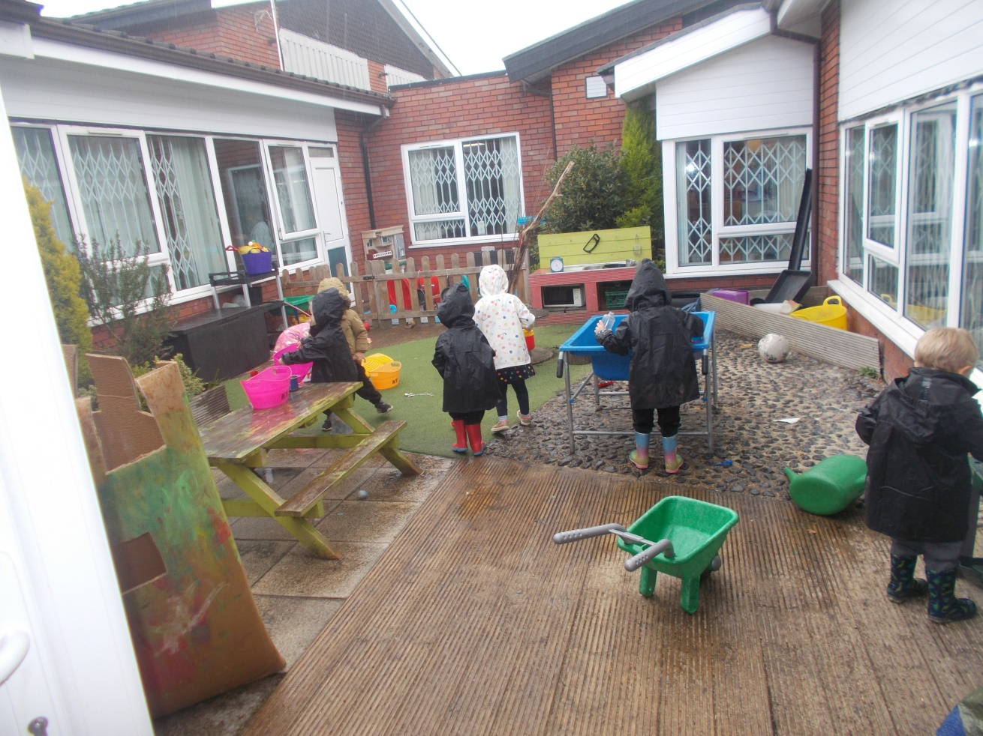[](https://www.google.co.uk/url?sa=i&url=https://coventry.wmgacademy.org.uk/about/ofsted/&psig=AOvVaw3g67YR8rWTzC4QxvEtjnny&ust=1622886957117000&source=images&cd=vfe&ved=0CAIQjRxqFwoTCIjC9Knb_fACFQAAAAAdAAAAABAD)

**9 Months - 4 year olds funding**.

**Fully Qualified Staff Team.**

**Monday-Friday 8:00am-5:00pm**

**At Squirrels Nursery we believe that every child should have the support they need to fulfil their potential.**

**You will find us:**

**Squirrels Nursery**

**Willow Trees Community Centre Redditch B98 9JG**

**Sessions**

**8:00-5:00 £60 9:00-4:00 £48 £7.50 additional hour.**

Contact us on 01527 65668 lynsey.abbotts@ymcaworcestershire.org.uk

Child’s Name: ___________________________________________________

Date of Birth: ____________________________________________________

Name of Parents/Guardians: _________________________________________

Home Address: ____________________________________________________

_________________________________________________________________

_________________________________________________________________

Home Tel: ________________________________________________________________

Email: ________________________________________________________________

Please tick the days and sessions you are interested in, we will endeavour to accommodate your child on your chosen session however this may not always be possible.

|  |  |  |  |  |  |
| --- | --- | --- | --- | --- | --- |
| **Sessions** | **Monday** | **Tuesday** | **Wednesday** | **Thursday** | **Friday** |
| 8am – 5pm |  |  |  |  |  |
| 9am – 4pm |  |  |  |  |  |

Do you, or will you, receive Government funding? 15 Hours/30 Hours

What date would you like your child’s place to start? ____________________________

Do you require a term time only place? _______________________________

Do you want your child to have a hot lunch and pudding at £2? Yes/No Any Dietary requirements? ___________________________________________

Signed: ______________________________________________________

Date: ________________________________________________________

Print Name: ___________________________________________________